ADAPTIVE DRIVER ASSISTANCE SYSTEM (ADAS)

An Advanced Driver-Assistance System (ADAS) in automobiles is a set of electronic systems that uses sensors like cameras and radar to help a driver with driving and parking functions. The goal is to increase car safety and reduce human error.
Key features of ADAS include:
- Adaptive Cruise Control (ACC): Maintains a set speed and a safe distance from the vehicle ahead.
- Automatic Emergency Braking (AEB): Automatically applies the brakes to prevent or mitigate a collision.
- Lane Keep Assist (LKA): Provides steering input to keep the vehicle centered in its lane.
- Blind Spot Detection: Warns the driver of vehicles in their blind spots.
- Parking Assist: Helps with steering during parking manoeuvres.
These systems act as a co-pilot, enhancing safety by automating, adapting, and improving vehicle systems for a safer driving experience. 🚗

Of course. Here is a good introduction to the development approach.

We are creating a suite of Advanced Driver-Assistance Systems (ADAS) by combining the power of Model-Based Design in Simulink with the industry-standard AUTOSAR architecture. Think of each ADAS feature—like Automatic Emergency Braking or Lane Keep Assist—as a "smart app" for the car. Our goal is to design, test, and prepare these apps for a real vehicle's electronic control unit (ECU).
Our process works in two main stages:
- Design and Simulation in Simulink: First, we use Simulink's graphical environment to build an executable model of the ADAS feature. This allows us to visually design the complex logic (often using Stateflow) and test its behaviour in a safe, virtual environment. We can simulate how the system reacts to different driving scenarios long before it's ever in a real car.
- Structuring for Production with AUTOSAR: A Simulink model itself doesn't go into a car. It needs to be structured to meet the rigorous standards of the automotive industry. That's where AUTOSAR (Automotive Open System Architecture) comes in. It's like a standardized operating system for car software. By using the Simulink AUTOSAR Blockset, we wrap our intelligent logic into a standardized Software Component. This involves defining its specific inputs, outputs, and how it communicates, ensuring it can be seamlessly integrated into any modern vehicle's software ecosystem.

I. AUTOMATIC BRAKING SYSTEM (AEB)

Automatic Emergency Braking (AEB) is a safety system that detects an imminent forward collision with another vehicle or obstacle and automatically applies the brakes to prevent or reduce the severity of the crash.

The logic used in AEB is based on calculating the Time to Collision (TTC), which follows these steps:
- Sense: Using radar and cameras, the system continuously measures the distance to the vehicle ahead and calculates the relative speed (how quickly your car is closing in on it).
- Predict: It calculates the Time to Collision (TTC) using the formula: TTC = Distance / Relative Speed. This predicts how many seconds you are from a potential crash if conditions remain the same.
- Act: The system acts in stages based on TTC thresholds.
  - Warning: If TTC drops below a warning threshold (e.g., 2.5 seconds), it first alerts the driver (Forward Collision Warning).
  - Braking: If the driver doesn't react and TTC drops below a critical threshold (e.g., 1.2 seconds), the system takes control and applies maximum braking force.

Simulink Model:
- Stateflow Logic Chart
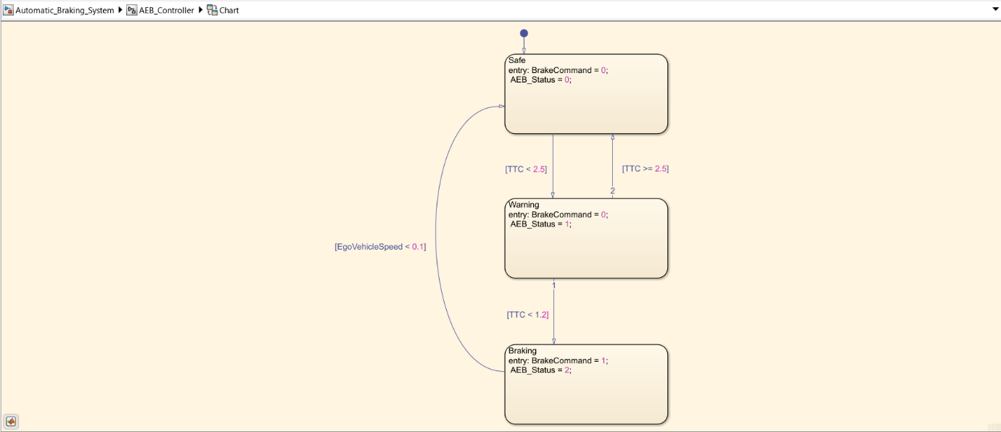
- Control Logic Unit

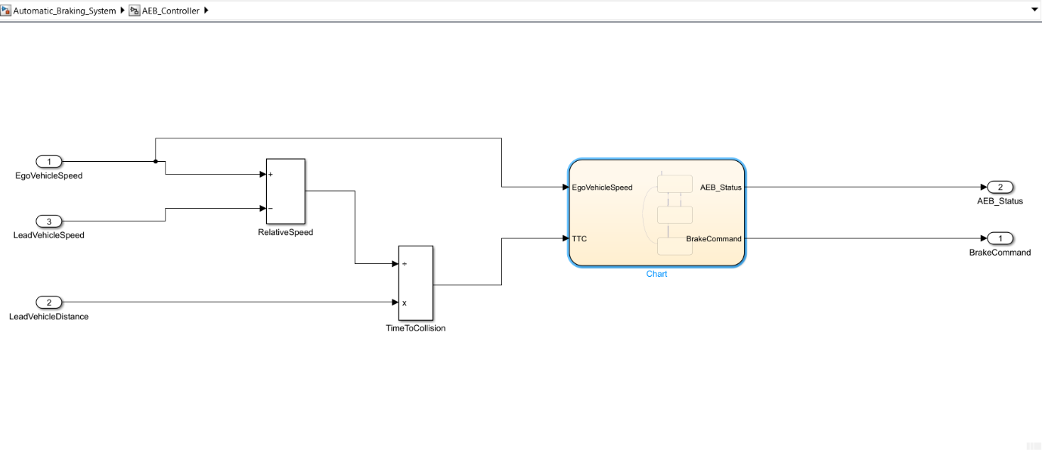

- Simulink Model
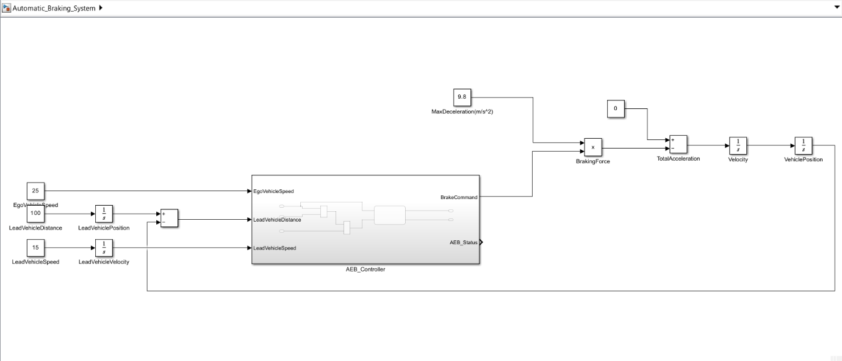

II. BLIND SPOT MONITORING (BSM)

Blind Spot Monitoring (BSM) is a safety system that uses sensors to detect vehicles in the driver's blind spot areas in adjacent lanes and provides a warning to help prevent a collision during a lane change.

The logic used in Blind Spot Monitoring follows these steps:
- Sense: Rear-facing radar sensors (or sometimes cameras) located in the vehicle's rear corners continuously scan a specific blind spot zone in the adjacent lanes. This zone typically starts near the side mirror and extends several meters backward.
- Decide: The system's logic activates when the vehicle is moving above a certain speed (e.g., 30 km/h) to prevent unnecessary warnings in parking lots or heavy traffic. It makes a decision based on whether an object detected in the zone is identified as another vehicle.
- Act (in stages): Unlike AEB, the system doesn't take control. It warns the driver in two stages:
  - Presence Warning: If a vehicle is detected in the blind spot, a visual icon (usually an amber light) illuminates steadily on the corresponding side mirror. This is a passive alert.
  - Action Warning: If the driver then activates their turn signal towards the occupied lane, the system escalates the warning. The visual icon flashes, and an audible chime or beep sounds to actively alert the driver of the immediate danger.

- Logic

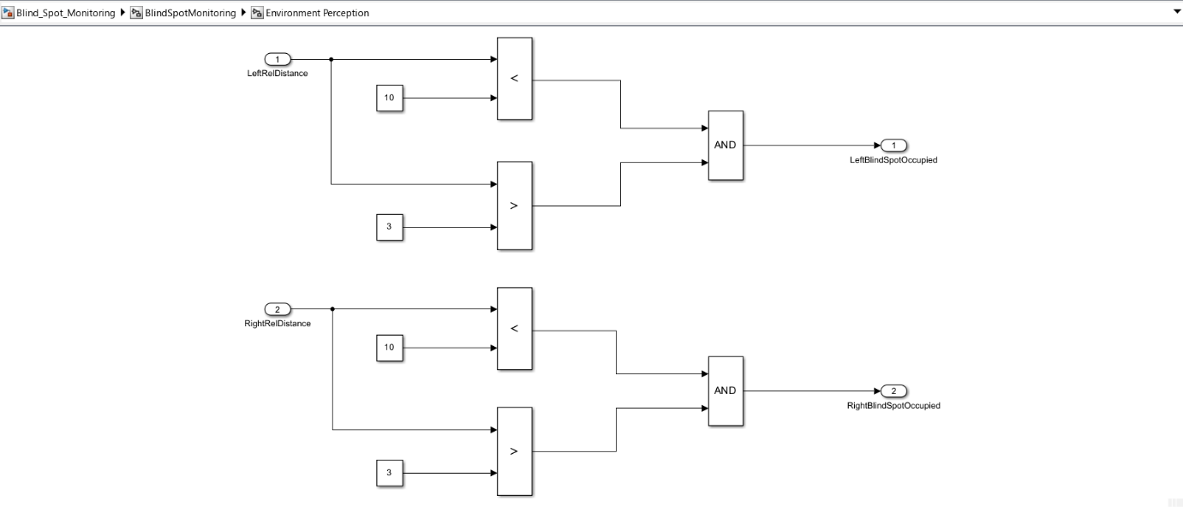

- Control Logic Unit

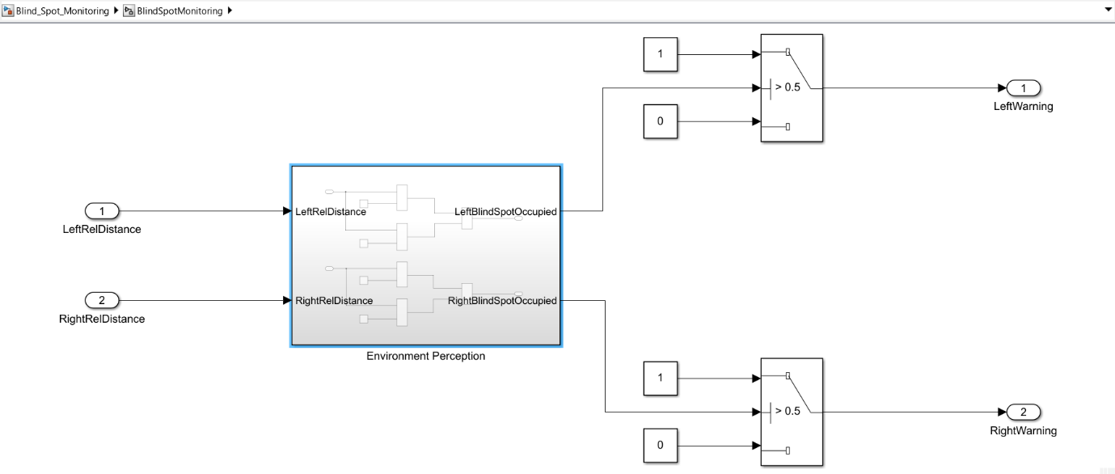

Simulink Model:

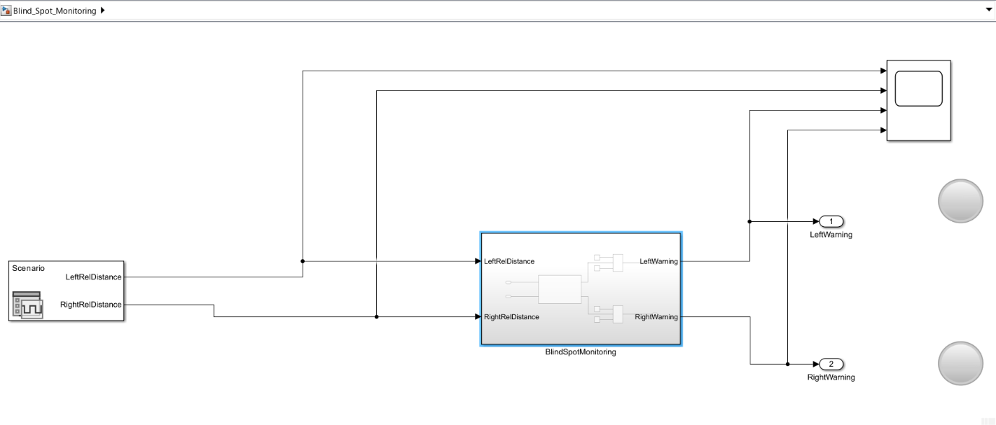

III. LANE KEEP ASSIST

Lane Keep Assist (LKA) is a comfort and safety system that uses a forward-facing camera to identify lane markings and automatically applies gentle, corrective steering torque to help keep the vehicle centered in its lane.

The logic used in Lane Keep Assist follows these steps:
- Sense: A forward-facing camera, typically mounted on the windshield, continuously watches the road ahead to detect lane markings. Image processing algorithms then calculate the vehicle's lateral position (its distance from the center of the lane) and its heading angle relative to the lane.
- Decide: The system activates only when certain conditions are met: the driver has enabled it, the vehicle is above a minimum speed (e.g., 60 km/h), and the camera can clearly see the lane lines. If the system detects that the vehicle is unintentionally drifting towards a lane marking without the turn signal on, it calculates the precise steering adjustment needed.
- Act: The controller sends a command to the vehicle's Electric Power Steering (EPS) system, which applies a small amount of corrective steering torque. This gentle nudge guides the car back toward the center of the lane. The force is intentionally light, allowing the driver to easily override it at any time by simply steering normally.

- Stateflow Logic

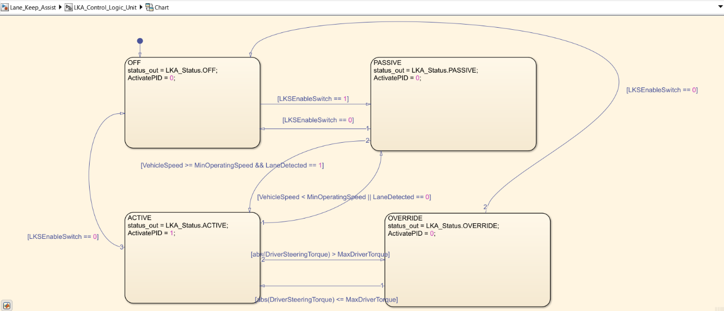

- Control Logic Unit

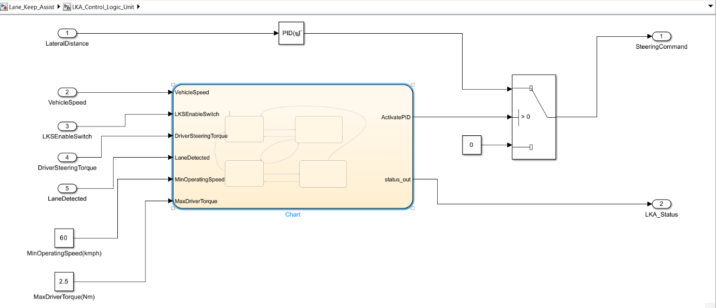

- Simulink Model

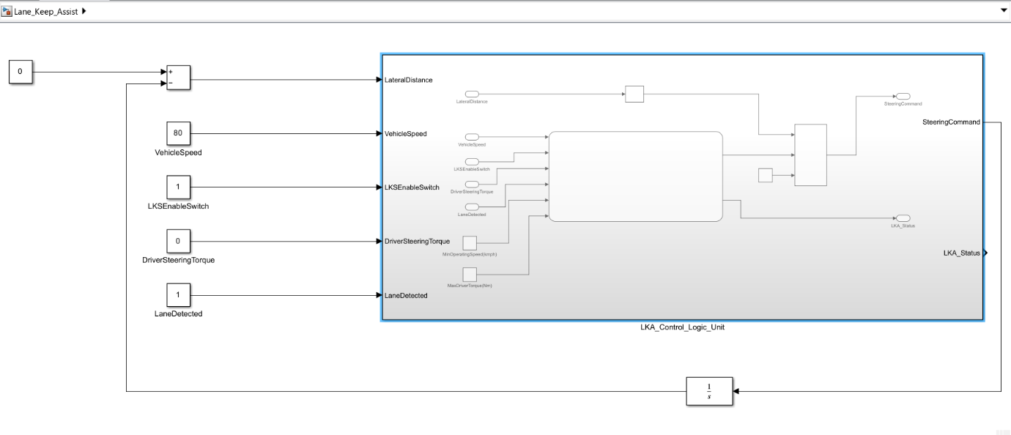

IV. PARKING ASSIST
Parking Assist is a driver-assistance system that automates the steering function to maneuverer a vehicle into a detected parallel or perpendicular parking space.

The logic used in Parking Assist follows these steps:
- Sense: The driver activates the system, and as they drive slowly, ultrasonic sensors on the bumpers scan the side of the road for a parking space that is large enough for the vehicle.
- Decide (Plan): Once a suitable space is identified, the system notifies the driver. The onboard computer then calculates a precise geometric path—a series of arcs and straight lines—required to enter the space. It then provides the driver with step-by-step instructions (e.g., "Stop," "Engage Reverse").
- Act: While the driver controls the accelerator, brakes, and gear shifter, the system takes full control of the steering. It sends commands to the Electric Power Steering (EPS) to turn the wheel automatically, precisely following the calculated path until the car is correctly positioned in the space.

The Stanley Controller is a popular and effective path-following controller used in autonomous driving and robotics. Its job is to calculate the correct steering angle to keep a vehicle precisely on a desired path or trajectory.
Think of riding a bicycle on a painted line. To stay on it, you simultaneously correct two things: your bike's direction and its sideways position. The Stanley Controller does exactly this by correcting two key errors:
- Heading Error (): This is the angle difference between the vehicle's current heading and the path's heading. It answers the question, "Is my car pointing in the same direction as the path?"
- Cross-Track Error (): This is the perpendicular distance from the vehicle's front axle to the closest point on the path. It answers the question, "Is my car positioned correctly on the path?"
The controller combines these two errors into a single steering command using the Stanley Law:
- is the final steering angle command.
- directly corrects the heading error.
- The arctan term corrects the cross-track error (). This term is designed to be aggressive at low speeds but smoother at higher speeds () to ensure stability. The gain () adjusts how sharply it tries to return to the path.
In summary, the Stanley Controller elegantly mimics how a human steers by simultaneously correcting both angular and positional errors to ensure the vehicle converges smoothly onto the desired path.

Codes:
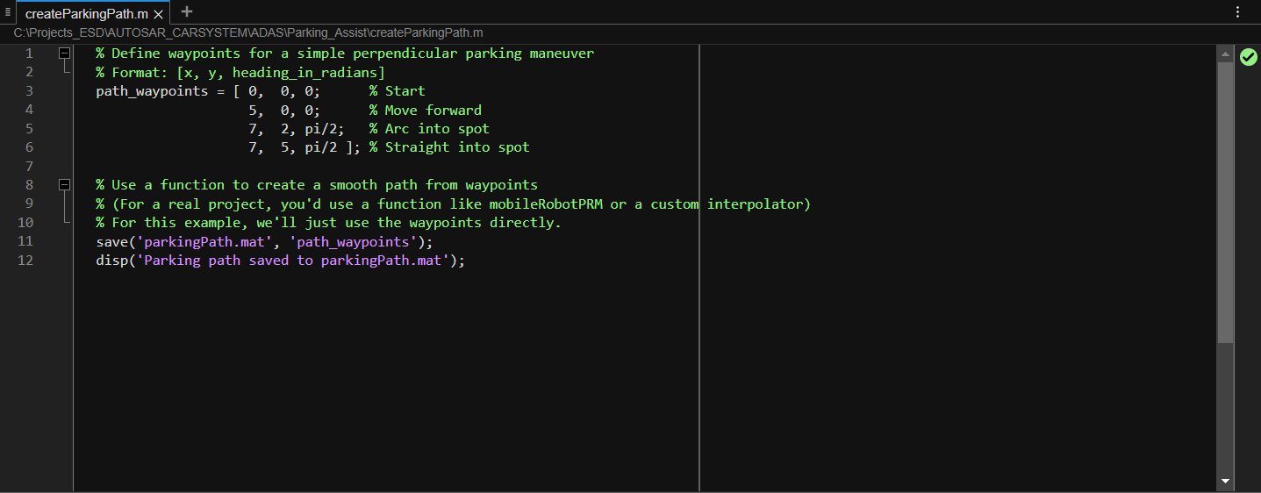
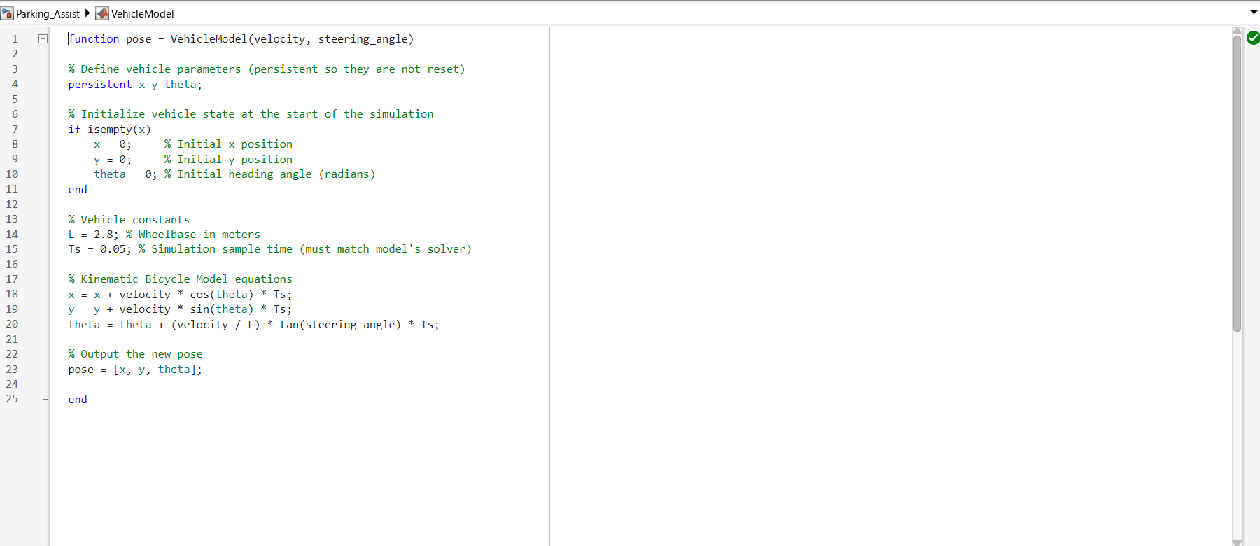
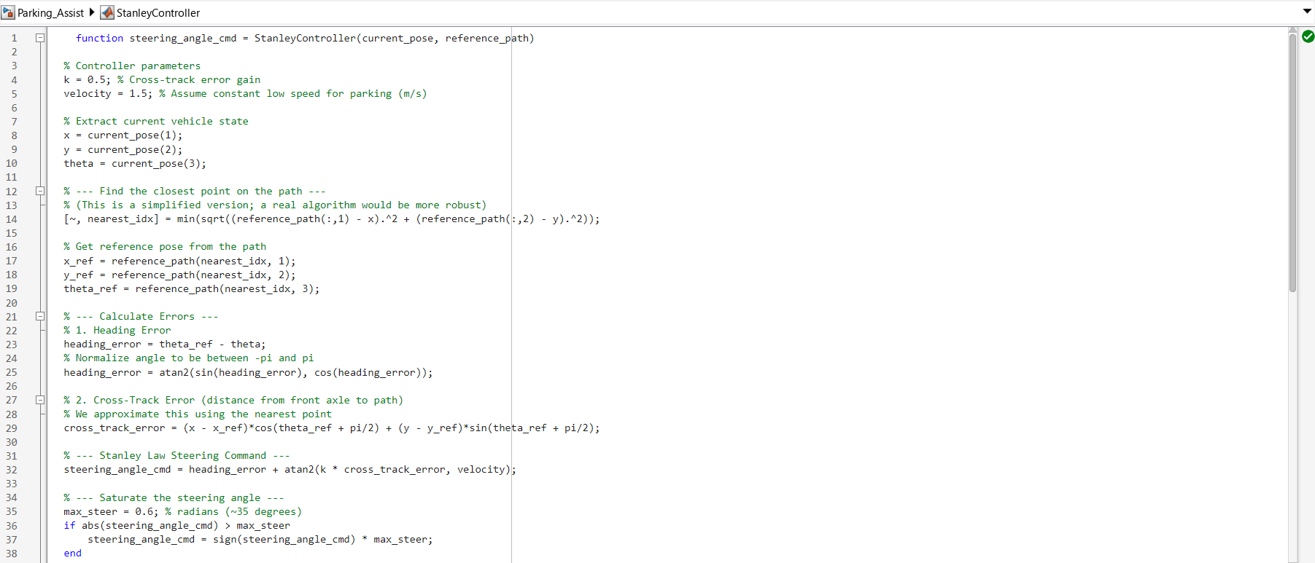

Simulink Model:
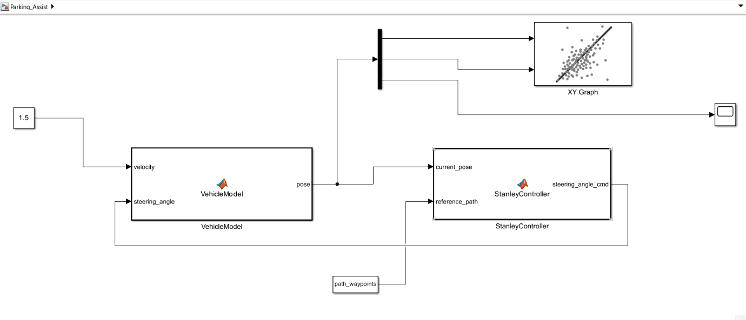

V. ADAPTIVE CRUISE CONTROL

Adaptive Cruise Control (ACC) is a driver-assistance system that automatically adjusts the vehicle's speed to maintain both a driver-set cruising speed and a safe following distance from the vehicle ahead.

The logic used in Adaptive Cruise Control operates in one of two modes:
- Sense: A forward-facing long-range radar (often combined with a camera) continuously scans the road ahead. It measures the distance to the vehicle in front and calculates its relative speed.
- Decide: The system's logic determines which mode to operate in:
  - Speed Control Mode: If no vehicle is detected ahead, the system functions like traditional cruise control, maintaining the speed set by the driver.
  - Distance Control Mode: If a slower vehicle is detected ahead, the system's priority changes. It calculates the necessary speed to maintain a pre-set following distance or time gap (e.g., 2 seconds) that the driver has selected. It will seamlessly switch back to speed control if the lane becomes clear.
- Act: The controller sends commands to the vehicle's powertrain and braking systems to manage speed:
  - To accelerate or maintain speed, it adjusts the engine throttle.
  - To decelerate, it can reduce throttle and apply moderate braking. This action is smooth and controlled, unlike the aggressive braking of an AEB system.

Stateflow Logic:
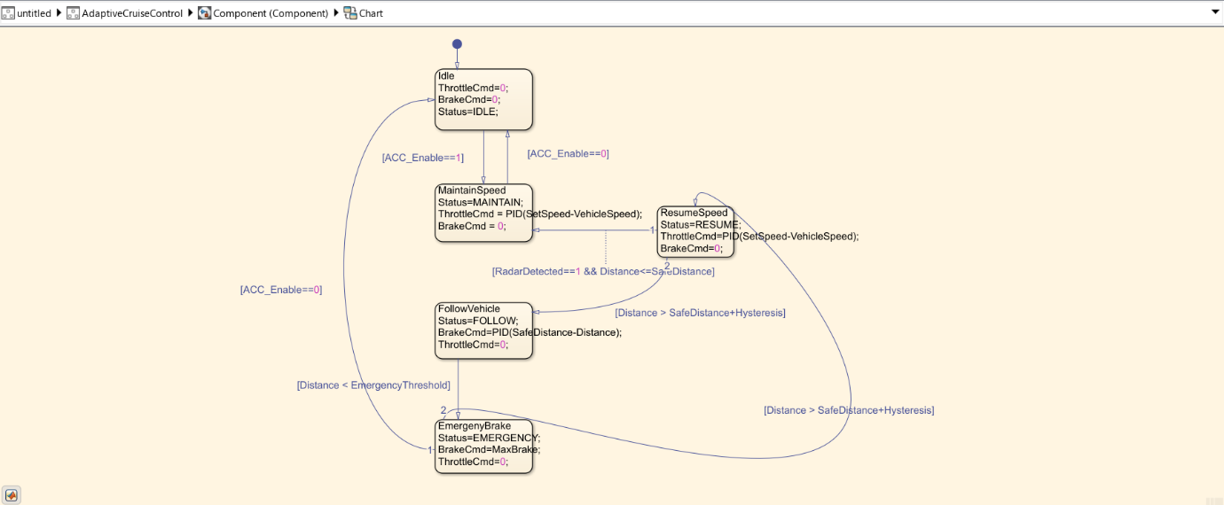
Simulink Model:
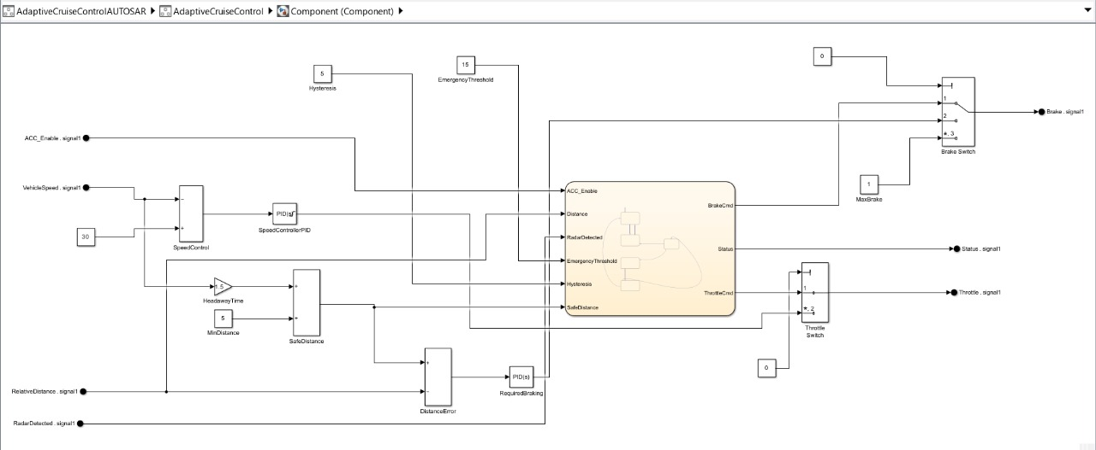
Autosar Component:
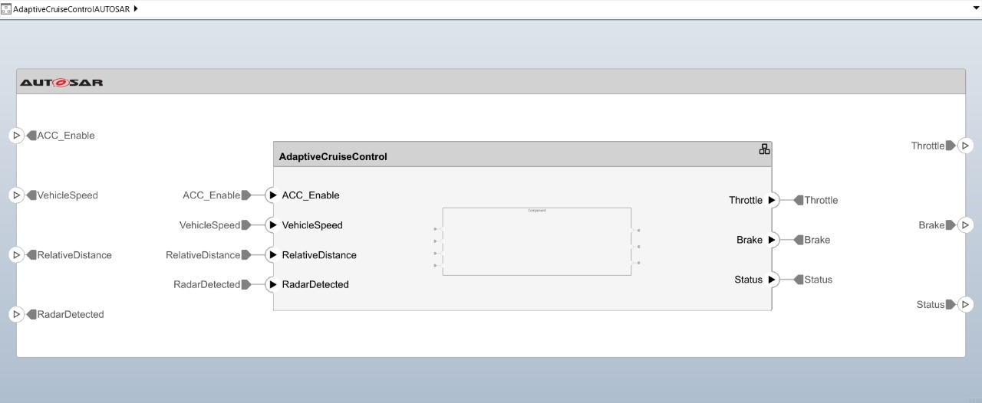

OUTPUTS:
I. Automatic Braking System
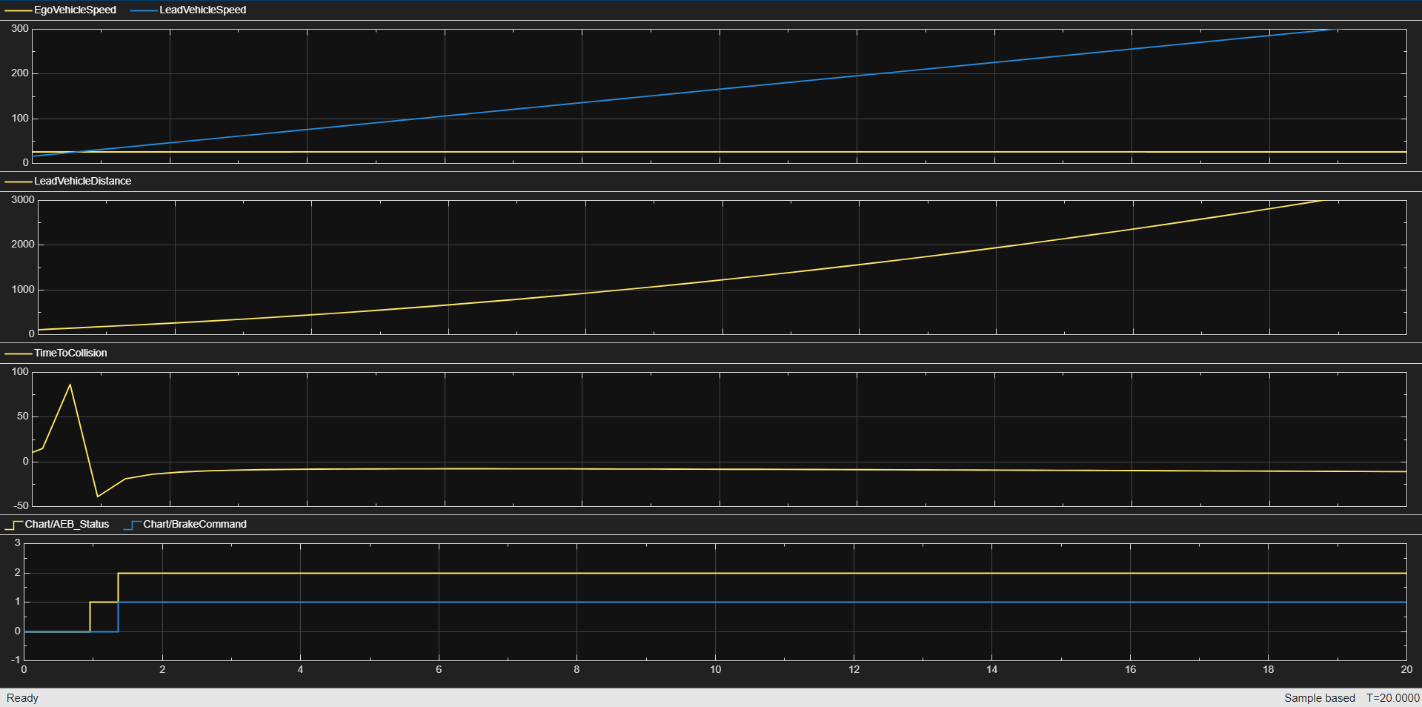

This graph shows a successful Automatic Emergency Braking event. The ego vehicle's speed (top plot, blue) is constant while the lead vehicle's is slower, causing the distance (second plot) and Time to Collision (third plot) to decrease. This triggers a warning and then full braking (bottom plot), stopping the car safely.

II. Blind Spot Monitoring System
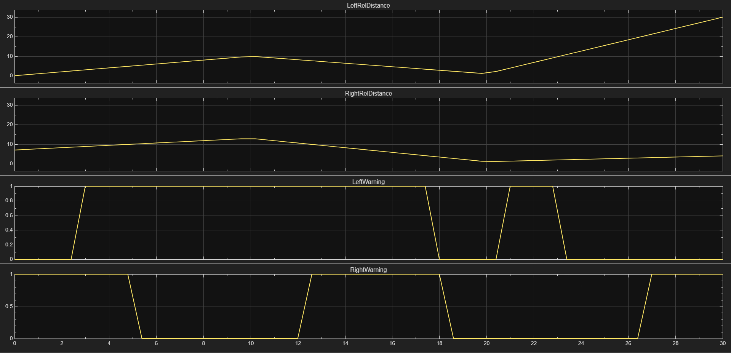

This graph shows a successful Blind Spot Monitoring system in action. The top two plots show the distance to vehicles on the left and right. When a vehicle gets too close (distance drops), the corresponding warning signal in the bottom plots activates (jumps to 1), alerting the driver.

III. Parking Assist
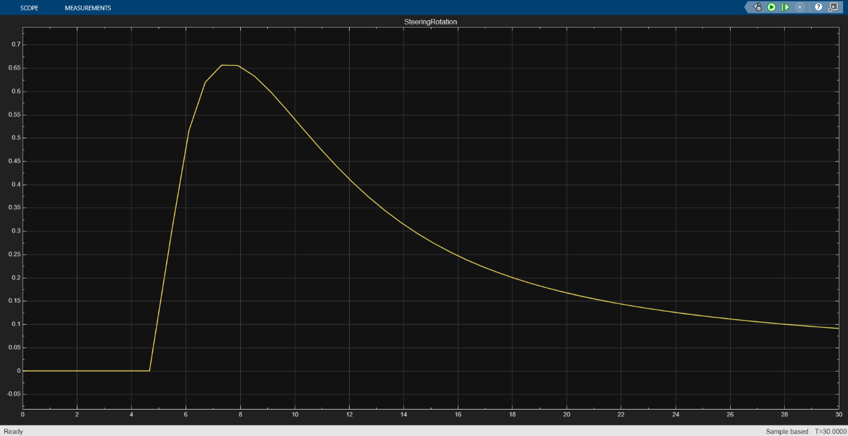
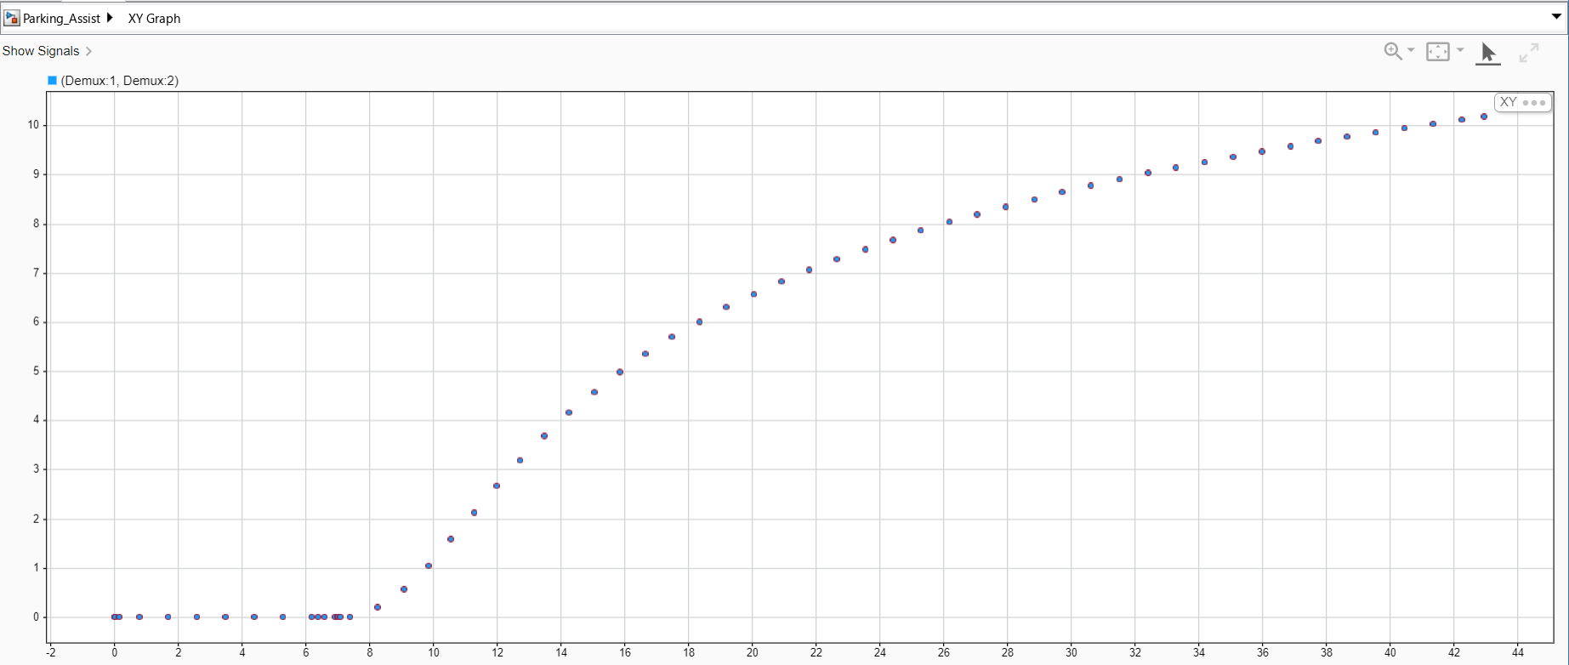

The XY Graph shows the vehicle's path. It starts by moving straight, then executes a smooth arc as it turns into the parking spot, and finishes with another straight movement. This demonstrates that the vehicle is correctly following the calculated trajectory.
The Steering Rotation graph shows the controller's action. The steering angle starts at zero, quickly turns to a maximum value to initiate the turn, and then smoothly decreases as the vehicle aligns with the parking spot. This confirms the controller is active and guiding the car precisely.

IV. Lane Keep Assist
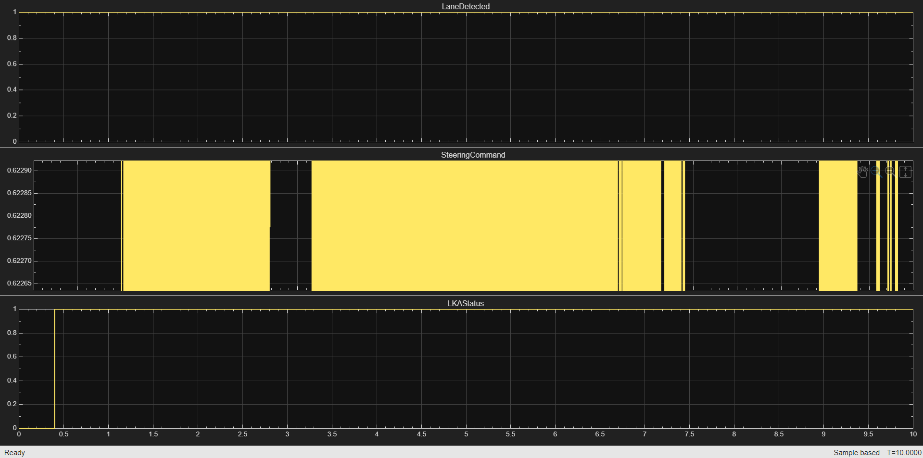
This graph shows a successful Lane Keep Assist system in action. The middle plot show the Steering Command given to the vehicle. When a vehicle gets far away from the lane the LKA Status jumps to 1.

